ICESat-2 ATL13 Bathymetry application to Alaska North Slope Region

Melanie Frost

4/21/2023

ICESat-2 launched on September 15, 2018, carrying the Advanced Topographic Laser Altimeter System (ATLAS) instrument which releases quadrillions of photos each second. The ATL13 dataset (Along Track Inland Surface Water Data)3 derives a variety of products from algorithms applied to ALT03 data, including an estimate of the water body depth. The following steps were completed to validate the ability of ATL13 to estimate water depths in the Alaska North Slope Region.

1. Identify ICESat granules for the period
   1. Use Caleb Spradlin’s CMR process to identify appropriate granules
   2. Subject to:
      * Bounding box: [-168, 67.3, -141, 73]
      * Months: July – September
      * Years: 2019-2022
   3. 782 granules identified
2. Extract data from granules and save as table
   1. The following data was extracted from the granules:
      * cycle = Tracks the number of 91-day cycles in the mission, beginning with 01.
      * water_id = HydroLAKES water body ID number
      * water_size = A=area, where 0=Not_Assigned, 1=A>10,000 sq km, 2=10,000>A>=1,000, 3=1,000>A>=100, 4=100>A>=10, 5=10>A>=1,6=1>A>=0.1, 7=0.01>A
      * water_type = Type of Inland Water Body, where 1=Lake, 2=Known, Reservoir, 3=(Reserved for future use), 4=Ephemeral, Water, 5=River, 6=Estuary or Bay, 7=Coastal Water
      * cloud_flag Consolidated cloud flag: 0=likely clear, 1=likely cloudy
      * bkgrd_flag = Describes the degree of background photons present in each short segment. 0:<=0.001, 1:<=0.01,2:<=0.05,3:<=0.1,4:<=0.3,5:<=0.5,6:>0.5
      * shallow_flag = Based on threshold checks for the estimated electromagnetic height bias. -3 if H_bias_EM < -0.10 (m); -2: < -0.05; -1: < -0.01; 0: < 0.01 (m); 1: < 0.05 : < 0.10; 3: > 0.10; 4: invalid
      * wind_flag = The height bias fit flag is set based on the value of the goodness of fit bias estimated as the difference between the centroid elevations of the

observed surface water histogram and fitted integrated water surface model histogram. -3 if H_bias_EM < -0.10 (m); -2: < -0.05; -1: < -0.01; 0: < 0.01 (m); 1: < 0.05 : < 0.10; 3: > 0.10; 4: invalid

* + - anomalies = 1 = Subsurface anomaly due to bottom likely; 2 = Subsurface signal may indicate bottom or other anomaly; 3 = Possible subsurface anomaly
    - rgt = the track on the earth at which a specified unit vector within the observatory is pointed.
    - seg_lat = Latitude of reporting location for all short segment statistics
    - seg_lon = Longitude of reporting location for all short segment statistics
    - snow_ice_flag = NOAA snow/ice flag scaled by ATL09 (0=ice-free water, 1=snow-free land, 2=snow, 3=ice
    - wave_flag = Standard deviation of water surface, calculated over long segments
    - depth = Depth from the mean water surface to detected bottom.
    - qual = num of photons 1: nominal; 2: possible afterpulse; 3: possible impulse response; 4: possible TEP
    - beam = which of 6 beams is the photon came from
    - start_date = UTC (in CCSDS-A format) of the first data point within the granule
    - sc_orient = tracks the spacecraft orientation between forward, backward and transitional flight modes
  1. 1,282,216 observations were compiled from this data

1. Filter the dataset by attributes
   1. The ATL13 dataset was filtered for quality and relevance
      * Limit inland water body type to lakes only. 482,262 observations remain
      * Limit start date to period between 1-July—15-Sep. 358,966 observations remain
      * Limit size to 0.1 square km or greater. 358,266 observations remain
      * Remove observations with clouds likely. 268,638 observations remain
      * Limit likely background photons to [< 50%]7. 268,638 observations remain
      * Limit estimated electromagnetic height bias to between [-.10 and .10]7. 268,638 observations remain
      * Limit height bias to between [-.10 and .10]7. 268,428 observations remain
      * Remove observations labeled as snow or ice. 263,303 observations remain
      * Limit wave height to <= 2 standard deviations from the long segment mean7. 248,439 observations remain
      * Remove observations without a depth variable and depths greater than 40 meters2. 115,655 observations remain
      * Only include observations with greater than 90% of photons labeled as “nominal” quality. 100,414 observations remain
      * Remove observations where the instrument was transitioning its orientation2. 100,414 observations remain.
   2. At the end of this filtering process, 100,414 observations remain
2. Filter the dataset by geography/spatial characteristics
   1. The refined dataset was filtered for geographic characteristics.
      * Only include observations withing the Alaska North Slope borough5. 90,837 observations remain.
      * Only include observations from lakes .45 square km or larger using the HydroLAKES4 boundary for float plane landing ability. 64,597 observations remain
      * Only include observations within the 2011 ABoVE Surface Water Extent1, 59,112 remain
      * Only include observations from lakes where the Global Surface Water occurrence value is 85% or greater6. 55,739 points remain.
3. Analyze results
   1. The global algorithms for estimating bathymetry do not seem to be effective in the Alaska North Slope region.
   2. An example of the results is shown for the lake with HydroLAKES ID number 1980 at 70.7368, -155.2979:

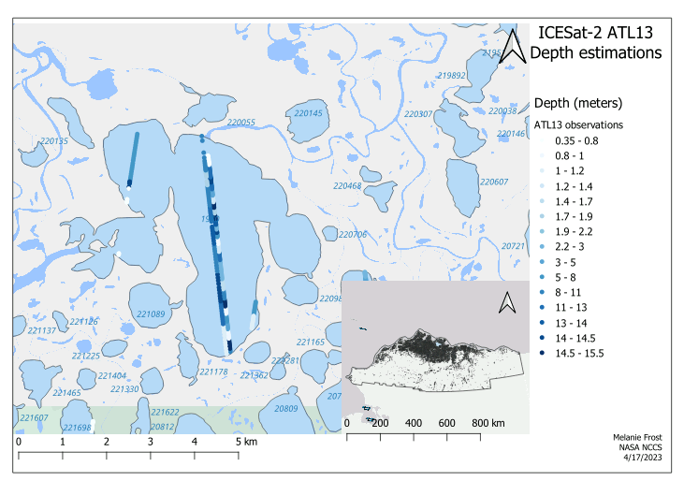

Depth = .85 m

Depth = 14.90 m

Depth = 6.27 m

* 1. Unexpected results for the Alaska North Slope Region include:
     + Depths more than 15m deep
     + Observations in a row with exactly the same depth
     + Segments near each other (approximately 23 m apart) with abruptly different depths
     + Very deep values near lake shore

References

1. Carroll, M.L., M.R. Wooten, C. Dimiceli, R.A. Sohlberg, and J.R.G. Townshend. 2016. *ABoVE: Surface Water Extent, Boreal and Tundra Regions, North America, 1991-2011*. ORNL DAAC, Oak Ridge, Tennessee, USA. https://doi.org/10.3334/ORNLDAAC/1324
2. Jasinski, M.; Stoll, J.; Hancock, D.; Robbins, J.; Nattala, J.; Morison, J.; Jones, B.; Ondrusek, M.; Pavelsky, T.; Parrish, C. *Algorithm Theoretical Basis Document (ATBD) for Along Track Inland Surface Water Data, ATL13, Release 5*, Release Date August, 2021, NASA Goddard Space Flight Center, Greenbelt, MD, 124 pp. DOI: 10.5067/RI5QTGTSVHRZ(August 2021)
3. Jasinski, M.; Stoll, J.; Hancock, D.; Robbins, J.; Nattala, J.; Morison, J.; Jones, B.; Ondrusek, M.; Pavelsky, T.; Parrish, C., and the ICESat-2 Science Team, 2021. *ATLAS/ICESat-2 L3A Along Track Inland Surface Water Data, Release 5*. Boulder, Colorado USA. NASA National Snow and Ice Data Center Distributed Active Archive Center. DOI:10.5067/ATLAS/ATL13.005 (August 2021).
4. Messager, M.L., Lehner, B., Grill, G., Nedeva, I., Schmitt, O. (2016): Estimating the volume and age of water stored in global lakes using a geo-statistical approach. Nature Communications: 13603. doi: 10.1038/ncomms13603. Data is available at www.hydrosheds.org
5. North Slope Science Initiative. *North Slope Borough Boundary*. 2016, Updated 2021. https://catalog.northslopescience.org/sv/dataset/514
6. Pekel, J.-F., Cottam, A., Gorelick, N., Belward, A. S., High-resolution mapping of global surface water and its long-term changes. Nature 540, 418-422 (2016). (doi:10.1038/nature20584)
7. Xu, N.; Zheng, H.; Ma, Y.; Yang, J.; Liu, X.; Wang, X*. Global Estimation and Assessment of Monthly Lake/Reservoir Water Level Changes Using ICESat-2 ATL13 Products*. Remote Sens. 2021, 13, 2744. https://doi.org/10.3390/rs13142744